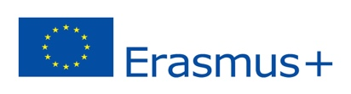
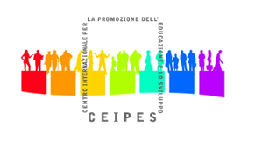
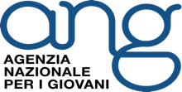
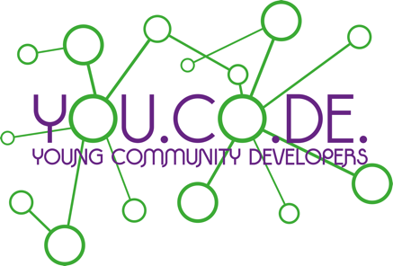

Training Course
Palermo (Italy) 11st – 18th April 2016
Erasmus plus KEY ACTION1: Mobility of learners and staff

APPLICATION FORM

Name
Surname
Sex
Date of birth
Complete address
Nationality
Passport/ID number
Telephone
E-mail
Sending organization
Please, fill all the boxes!
Few words about your academic background.
What is your job/studies/other at the moment?
What are your abilities in English language? (Please remember that the main language of the training course will be English)
What is your experience as active citizen?

Which are your main reasons for participating in this training course?

What is your knowledge about active citizenship, youth participation and community development?
Do you have any volunteering experiences?

Please tell us a need of your community that you would like to address.
What could be your contribution for the success of the seminar?
What do you want to gain from this training course (please give us the 3 most important outcomes of this seminar for you personally and for your organization)?
How do you plan to use the knowledge gained during this training course (please be specific)?
Are you willing to implement a local action in your community with the support of your sending organization as a follow-up of the training?
Please, tell us one of your favourites famous quotes!
Thank you!

