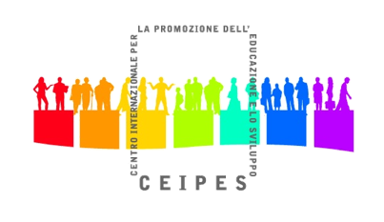
APPLICATION FORM

"Collaborative consumption - Chance for Sharing"
TC 23rd-30th July, Bakuriani, Georgia

Organized by Youth Together & International Center for Peace and Integration

Name
Surname
Sex
Date of birth
Place of birth
Address (complete)
Nationality
Telephone
E-mail
Passport/ID number
Please, fill all the boxes!
What is your job/studies/other at the moment?
What is your professional experience in third sector?

Do you have any knowledge or practical experience in collaborative consumption/sharing economy?
Which are your main reasons for participating in this training course?
What could be your contribution for the success of the training course?
What do you want to gain from this training course (please give us the 3 most important outcomes of this training for you personally)?
How do you plan to use the knowledge gained during this training course (please be specific)?
Do you have any special need? (dietary, health, etc…)
Please, tell us one of your favourites famous quotes!
Thank you!

